_________________________________________

CERTIFICATE OF ATTENDANCE

This Certificate is presented to

Name

The Virtual Forty-Third National HIPAA Summit
April 7-10, 2026

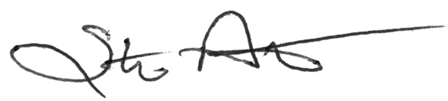
Steve Aitchison
Program Representative
__________________________________________

